





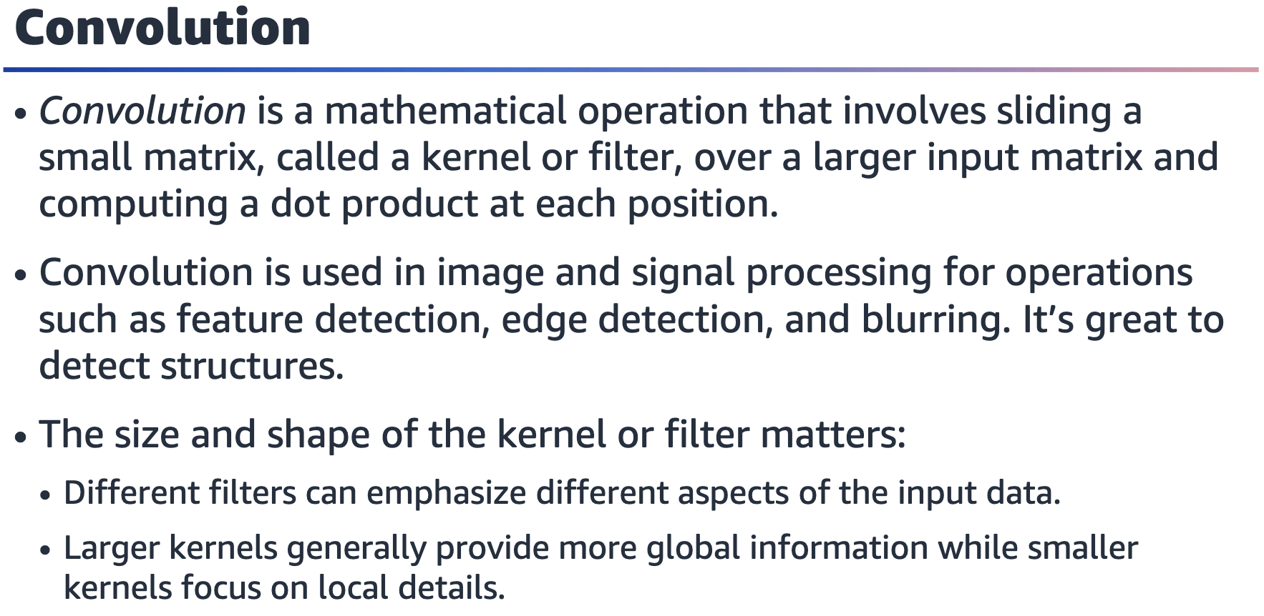

The resulting output matrix, which is also 2D, represents the spatial relationship

between the input elements and the filter weights. The output value at each position

is a function of the values in the input matrix and the filter weights.

One important consideration when using 2D convolution is the choice of kernel or

filter. Different filters can emphasize different aspects of the input data, such as high-

frequency features, edges, or smooth areas. The size and shape of the kernel also

affect the output, with larger kernels generally providing more global information and

smaller kernels focusing on local details.

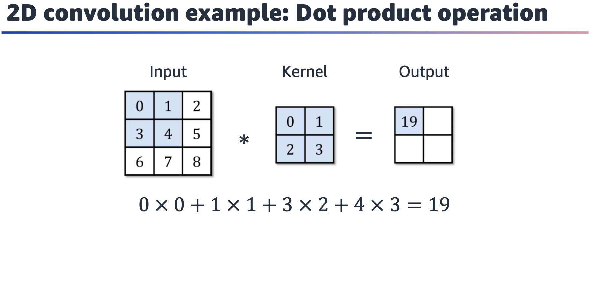

To calculate the 2D convolution, use the kernel and slide it over the input image. Multiply each element in the input with the corresponding position in the kernel. This

is called a dot product operation.

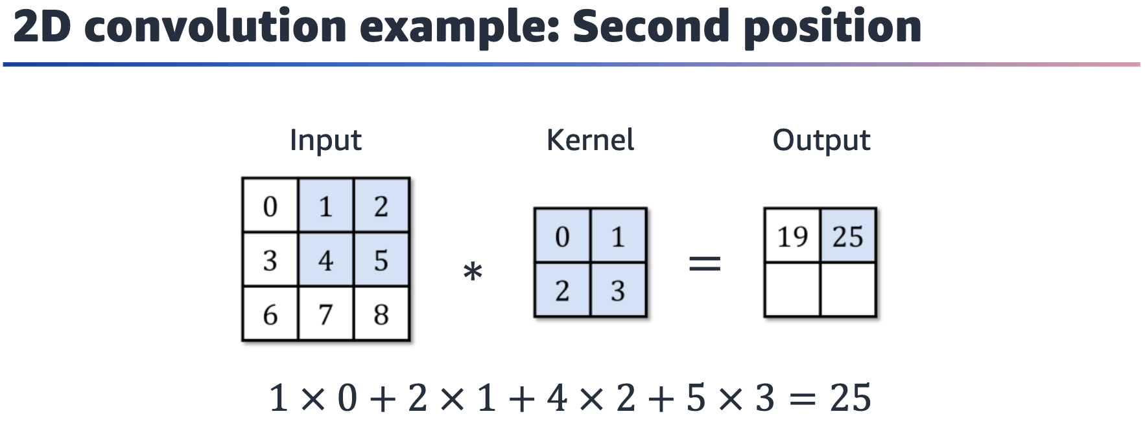

The

kernel moves to the second position. Now multiply the inputs with the

corresponding position in the kernel to create the second output value.

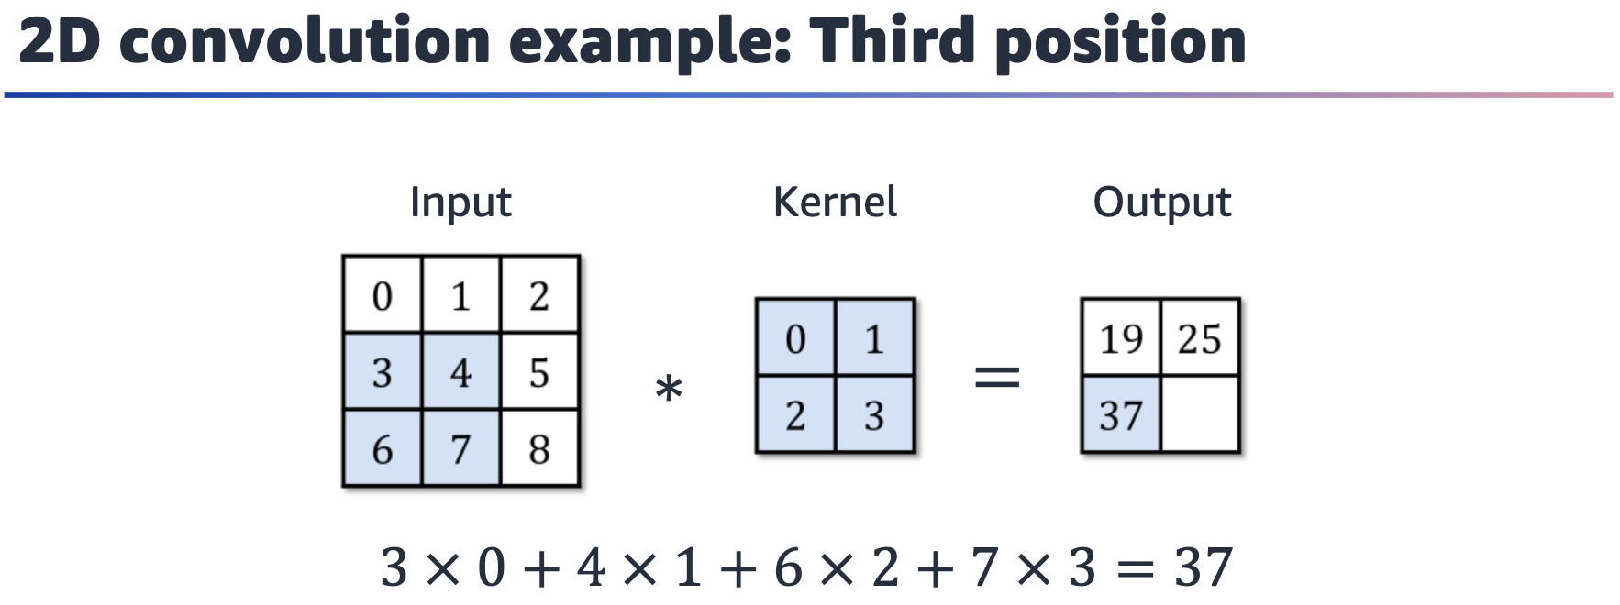

The kernel moves down to calculate the third output value.

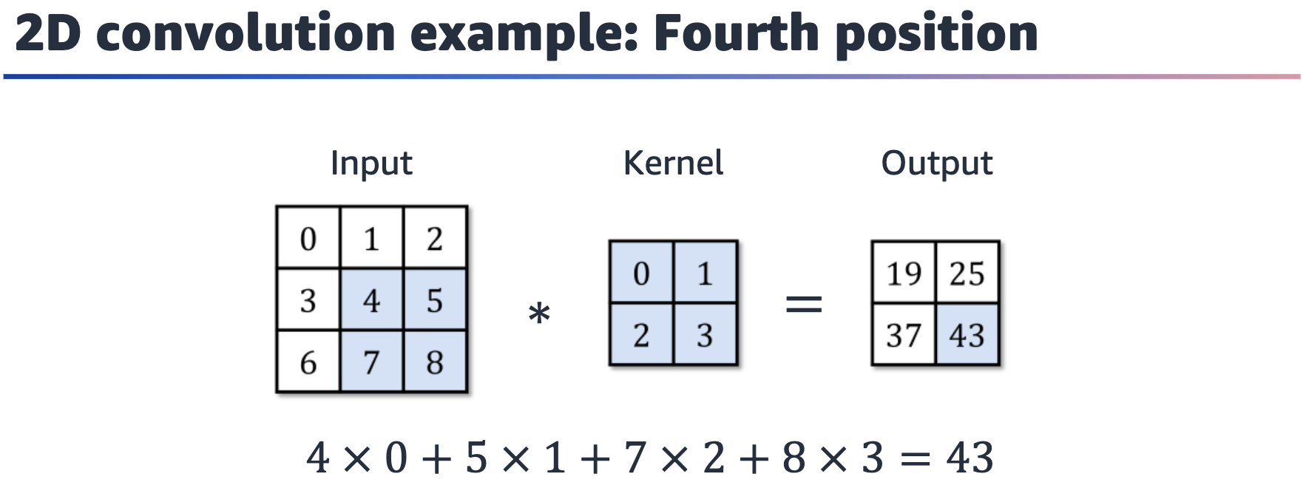

Finally, the last element is computed from the final position of the kernel.

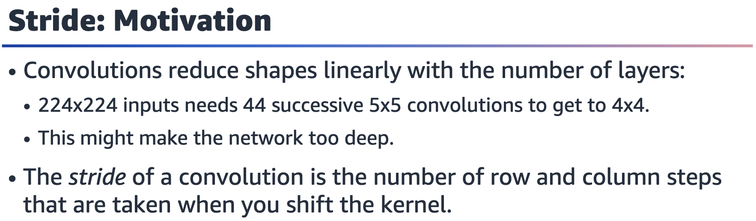

In image processing, stride refers to the step size that is used when applying a

convolutional filter to an input image. Specifically, stride is the number of pixels that

the filter is moved horizontally and vertically across the image when performing the

convolution.

A larger stride value means that the filter skips more pixels when moving across the

image, which results in a smaller output size. Conversely, a smaller stride value means

that the filter moves more slowly across the image, which results in a larger output

size.

Stride is an important parameter to consider when building deep learning models for

image processing. Increasing the stride can reduce the computational complexity of

the network and speed up the training process, but it can lead to a loss of information if important features are skipped. Decreasing the stride can improve the accuracy of the model by allowing it to capture more fine-grained details, but it also increases the computational cost and might lead to overfitting.

Overall, choose the stride value based on the specific requirements of the problem

and the available computational resources. In general, a smaller stride value is better

for tasks that require high accuracy and fine-grained feature detection, while a larger

stride value is better for tasks that require fast computation and coarse feature detection.

An animation of stride is available at:  
<https://github.com/vdumoulin/conv_arithmetic/blob/master/gif/padding_strides.gif>

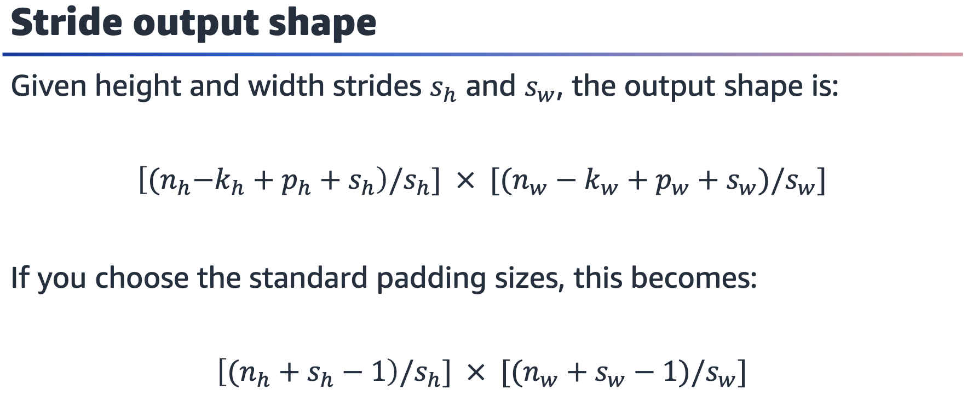

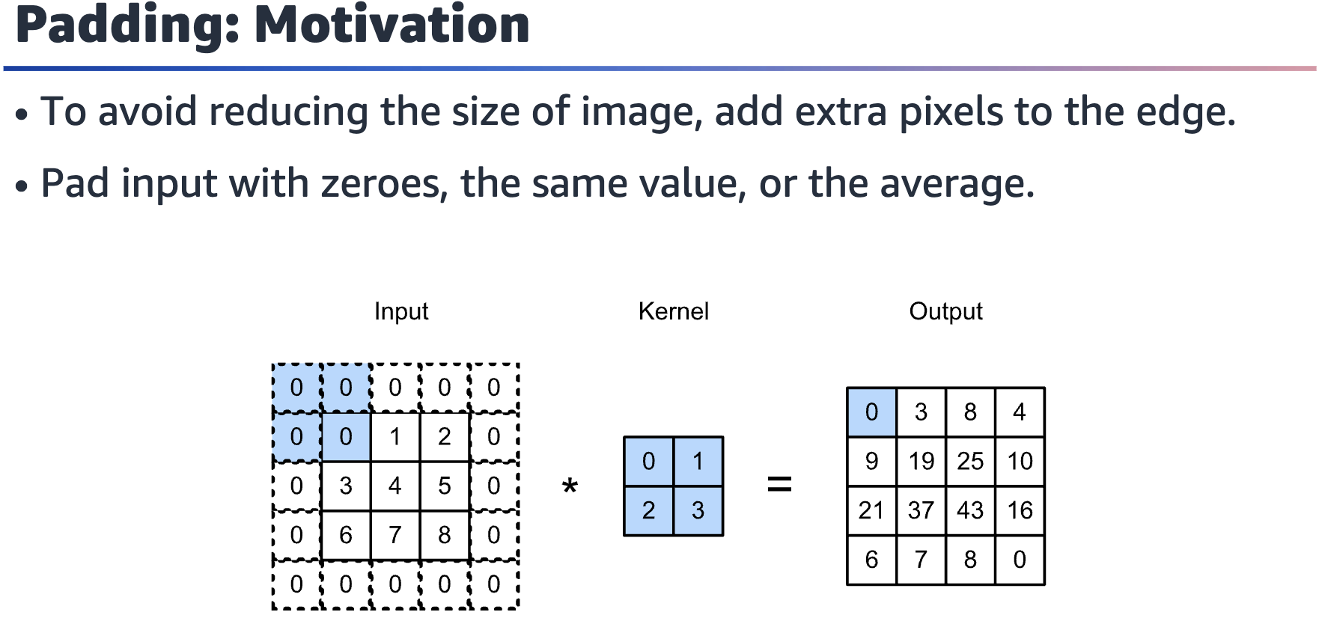

Graphic of a grayscale input image with certain pixel values highlighted and an additional border of pixels with value 0. The input is multiplied with a kernel. The result of the multiplication shows an output that has preserved the size of the original input.

In image processing, padding refers to the process of adding extra pixels to the edges

of an image before applying a convolutional operation to it. Padding is used to preserve the spatial dimensions of the input image after the convolutional operation, and it’s an important technique in deep learning and AI.

When a convolutional filter is applied to an image, the edges of the image are not processed in the same way as the central pixels. This can lead to a reduction in the size of the output image after the convolution, which can be problematic when trying to build deep networks with multiple layers of convolutions. Padding addresses this issue by adding extra pixels to the edges of the image, which ensures that the edge pixels are processed in the same way as the central pixels.

Padding can be done in different ways, such as adding zeros or replicating the edge

pixels, and the amount of padding can vary depending on the size of the filter and the

desired output dimensions.

By using padding, it’s possible to preserve the spatial dimensions of the input image,

which can lead to better performance in image classification, object detection, and

other computer vision (CV) tasks.

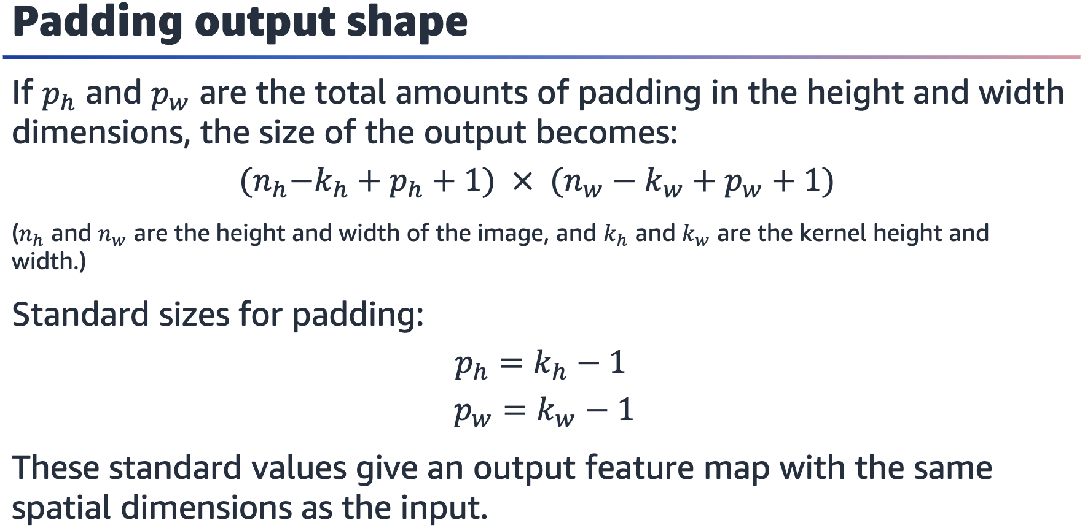

Note that the padding specified here is the total padding per dimension. However,

PyTorch requires padding to be specified as the amount added to a single side for

each dimension.

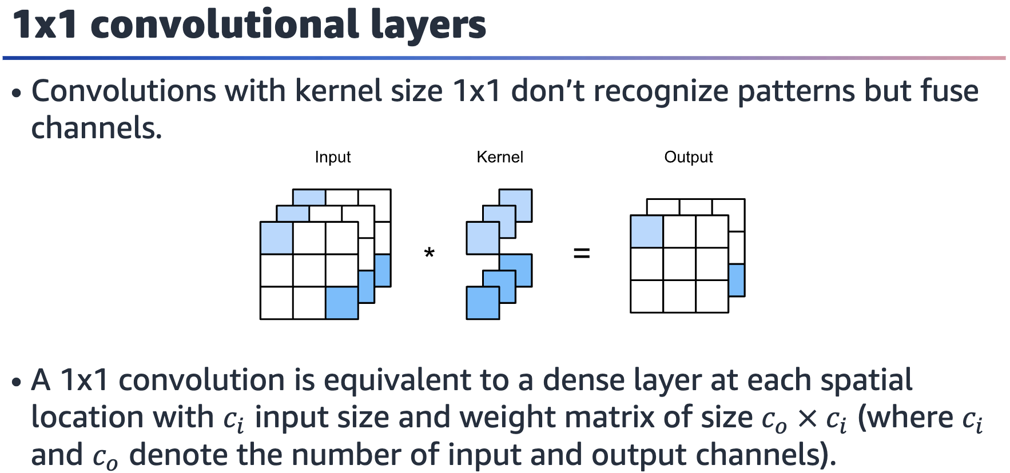

A 1x1 convolutional layer, also known as a pointwise convolution, is a type of convolutional layer that is used in deep learning models for image processing and

other applications.

Unlike traditional convolutional layers, which use square or rectangular filters to scan

the input image, a 1x1 convolutional layer uses a 1x1 filter, which only considers

individual pixels in the image. Specifically, the filter is applied to each pixel in the

input tensor independently. This results in a new tensor with the same spatial

dimensions as the input but a different number of channels. The reduction in number

of channels is a consequence of the dot product between the image matrices and the

kernel over multiple channels.

One common application of 1x1 convolutional layers is in the design of network

architectures, where they are used to reduce the number of channels and reduce

computational complexity. For example, a 1x1 convolutional layer can be inserted

between two larger convolutional layers to reduce the number of channels before the

next convolution, without changing the spatial dimensions of the data.

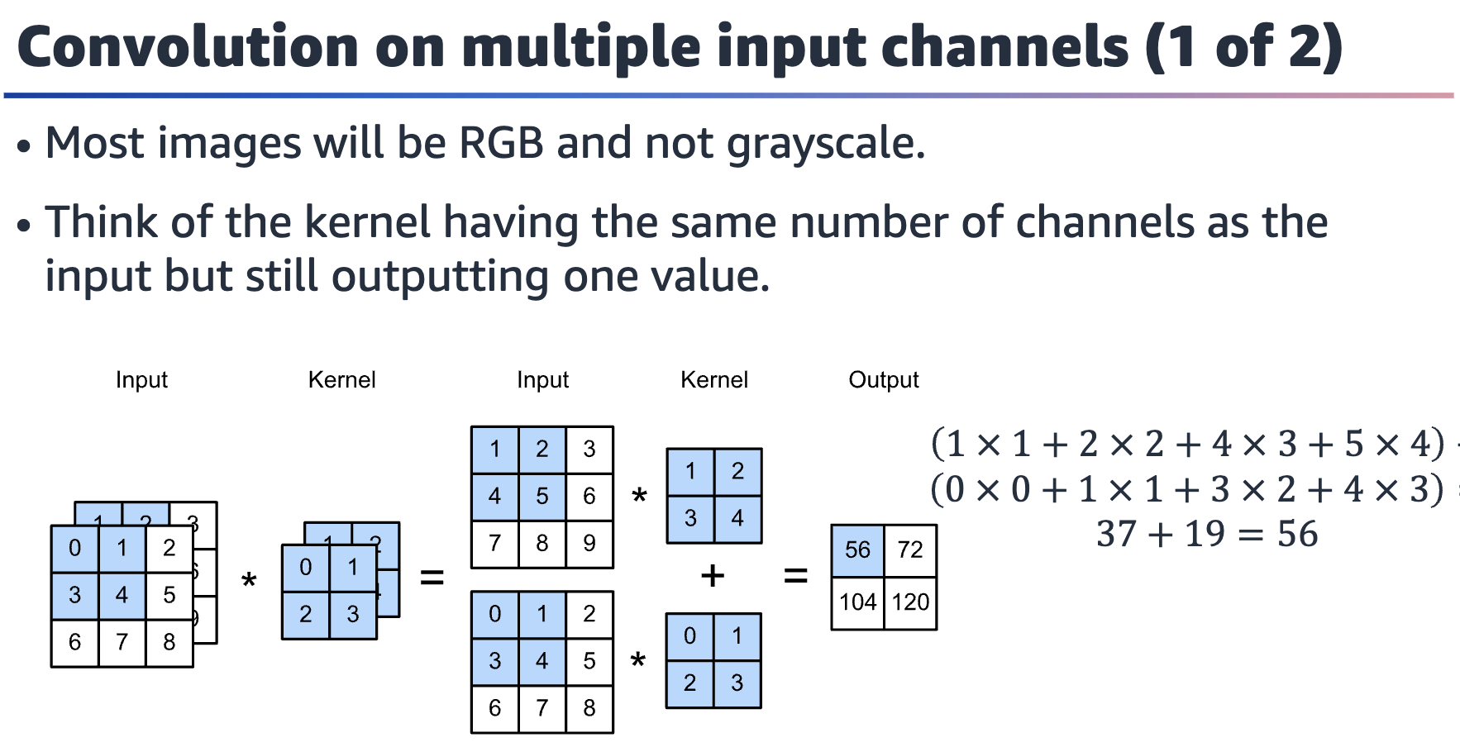

Graphic of a two-layer input image where each layer is multiplied by a kernel. The result is a one-layer output (the additive result of the layer-wise kernel multiplication).

You can also apply convolution to color images. In that case, you can use different

kernels for each color channel of the image.

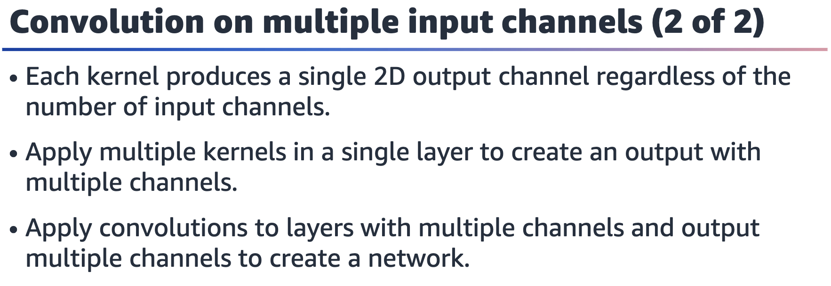

A convolutional neural network (CNN) is a combination of the convolution technique

and some additional methods that help identify patterns. More details will be

covered in the next lesson.

